Topic as per syllabus | As per Text Book
Introduction: Computer-System Architecture, Operating System Structure, Operating system operations. | 1.3 Computer-System Architecture  1.4 Operating-System Structure  1.5 Operating-System Operations
System Structures: Operating system services, User and Operating system  interface, System Calls, Types of System calls, System programs, Operating System Structure | 2.1 Operating-System Services  2.2 User and Operating-System  Interface  2.3 System Calls  2.4 Types of System Calls  2.5 System Programs  2.7 Operating-System Structure
Process Concept: Process Concept, Process Scheduling, Operations on  Processes, Inter-process Communication. | 3.1 Process Concept  3.2 Process Scheduling  3.3 Operations on Processes  3.4 Interprocess Communication

Operating System Concepts Abraham Silberschatz, Peter Baer Galvin, Greg Gagne 9 th John Wiley & Sons, Inc. 2012

Chapter 1
  - Computer system Architecture
    - Single-Processor Systems
    - Multiprocessor Systems
    - Clustered Systems
  - Operating System Structure
  - Operating System Operations
    - Dual-Mode Operation
    - Timer

  - Computer-System Architecture:
In Section 1.2, we discussed the general structure of a typical computer system. These systems can be organized in various ways, primarily categorized by the number of general-purpose processors used.
    - Single-Processor Systems
Most systems use a single processor, but these can vary greatly, from PDAs to mainframes. A single-processor system has one main CPU that executes general-purpose instructions, including user processes. However, special-purpose processors, such as disk, keyboard, and graphics controllers, are also commonly used. These processors run limited instruction sets and don’t execute user processes. They are either managed by the operating system or work autonomously, relieving the main CPU from specific tasks. Despite these special processors, a system remains single-processor if it has only one general-purpose CPU.
    - Multiprocessor Systems
Multiprocessor systems, which have two or more processors in close communication, offer three main advantages:
- Increased throughput: More processors can speed up tasks, but the gain is less than proportional due to overhead and resource contention.
- Economy of scale: Multiprocessors are cost-effective since they share peripherals, storage, and power, reducing costs compared to multiple single- processor systems.
- Increased reliability: If one processor fails, others can take over its tasks, minimizing system downtime and improving overall reliability.
Increased reliability is crucial in many systems, and graceful degradation allows a system to continue operating with reduced performance when some hardware fails. Fault tolerance goes further, ensuring operation even if any single component fails. For example, the HP Non-Stop system uses duplicate CPUs that compare results, halting and recovering from faults if necessary, though it's costly.
Multiprocessor systems can be asymmetric or symmetric. In asymmetric multiprocessing (AMP), one master processor controls the system, and other processors perform predefined tasks. In symmetric multiprocessing (SMP), all processors are equal, performing tasks within the OS, allowing for better performance and flexibility. Most modern systems, including Windows, Linux, and Solaris, use SMP.
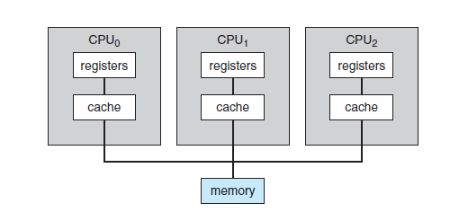

Figure 1.6 Symmetric multiprocessing architecture

Recent trends include multi-core CPUs, which combine multiple processors on a single chip, and blade servers, where independent processor boards with their own OS run in a shared chassis. Blade servers blur the lines between multiprocessor systems and can have multiple processors on a single board.

    - Clustered Systems
A clustered system is a type of multiple-CPU system where two or more individual systems are linked together, typically via a local-area network (LAN) or a faster connection like InfiniBand. These systems share storage and provide high availability, ensuring service continues even if a system fails. Cluster software monitors nodes, and if one fails, another can take over its tasks with minimal disruption to users.
Clustering can be asymmetric, with one machine in standby mode, or symmetric, where all nodes run applications and monitor each other. Symmetric clustering is more efficient. Other types include parallel clusters, where multiple systems access shared data, and WAN clustering, which extends clusters over large distances. Technologies like Storage Area Networks (SANs) enable shared storage, improving performance and reliability by allowing any node to take over tasks if another fails.
  - Operating-System Structure:
An operating system (OS) provides the environment for executing programs and managing system resources. One key function of an OS is multiprogramming, which increases CPU utilization by keeping multiple jobs in memory and switching between them when one job waits for I/O operations. This ensures the CPU is never idle as long as there are jobs to execute.
A job in an operating system is a high-level unit of work submitted by a user (often in batch systems), while a process is a program instance currently under execution by the CPU. Jobs represent what needs to be done, whereas processes represent how that work is executed.
📁 Job = Print Request 🖨 Process = Printer Actually Printing
Job is what the user wants done.
Process is how the OS gets it done.

Feature | Job | Process
Exists in | Job queue | Ready/Running queue
Has PID? | No | Yes
Uses CPU? | No | Yes
Has memory allocated? | No | Yes
Scheduled by CPU scheduler? | No | Yes

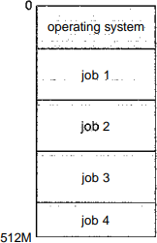

Figure 1.7 Memory layout for a multiprogramming system.

An extension of multiprogramming is time-sharing (or multitasking), where the CPU switches rapidly between jobs, allowing users to interact with programs while they run. In a time-shared system, multiple users can access the computer simultaneously, with each user appearing to have the system dedicated to them. The system responds quickly to user input, typically within a second, providing an interactive experience.
A time-shared operating system allows multiple users to share a single computer by rapidly switching between programs. Each user has a separate program in memory, known as a process. Since interactive I/O (like user inputs) can be slow, the CPU switches to other user programs to avoid idling.
Programs are initially stored on the disk in a job pool and are loaded into memory as needed. This requires memory management and CPU scheduling, which are covered in the respective chapters. Virtual memory allows programs to run even if they don’t completely fit in physical memory, enabling larger applications. Time-sharing systems also manage disk storage through a file system and provide mechanisms for job synchronization, communication, and protection of resources.
  - Operating-System Operations:
Modern operating systems are interrupt-driven, meaning they remain idle until an interrupt or trap occurs. A trap is a software-generated interrupt caused by errors or specific user requests. The operating system responds to interrupts with an interrupt service routine. To prevent one program's errors from affecting others, the operating system ensures that each program is isolated, protecting the system from malicious or incorrect behavior. This isolation ensures that a bug in one program doesn't disrupt other processes or the operating system.
    - Dual-Mode Operation
To ensure proper execution, operating systems differentiate between user code and OS code using hardware support for different execution modes: user mode and kernel mode. A mode bit indicates the current mode (0 for kernel, 1 for user). The system starts in kernel mode during boot, switches to user mode when running applications, and returns to kernel mode for system calls or interrupts. This dual-mode operation protects the OS and user programs by restricting privileged instructions (like I/O control and interrupt management) to kernel mode. Any attempt to execute privileged instructions in user mode triggers a trap to the OS.

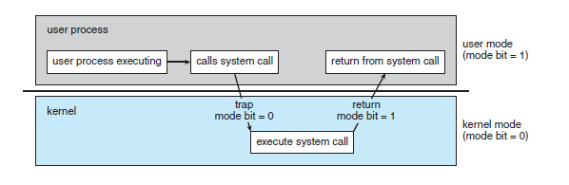

Figure 1.8 Transition from user to kernel mode.
System calls allow user programs to request services from the operating system by invoking a trap to a specific location in the interrupt vector. This triggers a software interrupt, switching the system to kernel mode. The OS examines the system call, checks parameters, executes the request, and returns control to the user program. Without dual- mode operation, older systems like MS-DOS lacked protection, allowing errors to overwrite the OS or cause issues with multiple programs accessing devices simultaneously. Modern CPUs, like Intel’s Pentium, support dual-mode, enhancing protection. Hardware errors are detected, leading to traps that transfer control to the OS, which handles errors by terminating programs and providing error messages and memory dumps for troubleshooting.
    - Timer
To ensure the operating system maintains control over the CPU, a timer can be used to prevent user programs from getting stuck or not returning control to the OS. The timer is set to interrupt after a specified period, either fixed or variable. The OS configures a counter that decrements with each clock tick, and when it reaches 0, an interrupt occurs. This ensures the OS can regain control if a program exceeds its allowed runtime. For example, a program with a 7-minute limit would have its counter initialized to 420, and the OS terminates the program if the counter reaches 0.

Chapter 2
  - Operating-System Services
    - User Interface
    - Program Execution
    - I/O Operations
    - File-System Manipulation
    - Communication
    - Error Detection
    - Resource Allocation
    - Accounting
    - Protection & Security
  - User Operating-System Interface
    - Command Interpreter
    - Graphical User Interfaces
  - System Calls
  - Types of System Calls
    - Process Control
    - File Management
    - Device Management
    - Information Maintenance
    - Communication
    - Protection
  - System Programs
    - File Management,
    - Status Information
    - File Modification
    - Programming Language Support
    - Program Loading & Execution
    - Communication
  - Operating System Structure
    - Simple Structure
    - Layered Approach
    - Micro kernels
    - Modules

  - Operating-System Services:

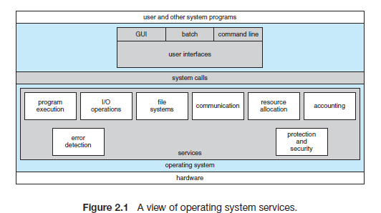

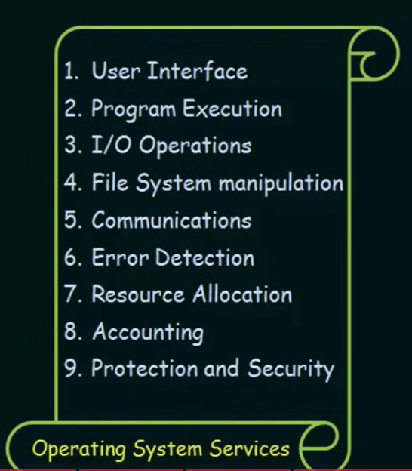
An operating system creates an environment for program execution, offering various services to programs and users. While the services differ across operating systems, common types exist to simplify programming tasks and enhance convenience for developers.

Operating systems offer essential services to users and programs:
- User Interface (UI): Provides ways for users to interact with the system, such as command-line interfaces (CLI), batch interfaces, or graphical user interfaces (GUI) featuring windows, menus, and pointing devices.
- Program Execution: Loads and executes programs, allowing them to terminate normally or with errors.
- I/O Operations: Manages input/output operations for files and devices, ensuring efficient and protected access to hardware.
- File-System Management: Enables file and directory operations, such as creating, deleting, reading, writing, searching, and managing permissions.
- Communication: Facilitates data exchange between processes, either on the same system or across networks, using shared memory or message passing.
- Error Detection: Monitors and handles errors in hardware, devices, or user programs to maintain system stability and support debugging.

Operating systems ensure efficient system operation with key functions:
- Resource Allocation: Manages and allocates resources like CPU, memory, and I/O devices among multiple users or jobs, using scheduling and allocation routines for optimal performance.
- Accounting: Tracks resource usage to support billing, usage statistics, and system improvements.
- Protection and Security: Ensures controlled access to system resources, safeguards against unauthorized interference, and requires user authentication. It includes securing external devices and monitoring for unauthorized access to maintain overall system integrity.

  - User Operating-System Interface:
Users can interface with an operating system in two main ways: through a command-line interface (CLI) for direct command entry or a graphical user interface (GUI) for interaction using visuals like windows and menus.
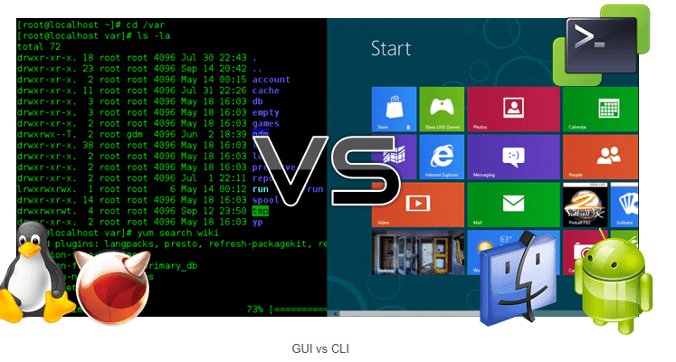

    - Command Interpreter
Operating systems handle command interpreters in two ways:
- Integrated Command Interpreter: Some systems include it in the kernel, while others, like Windows XP and UNIX, treat it as a separate program running at login. UNIX and Linux offer multiple interpreters (shells), such as Bourne, C, and Korn shells, with users selecting based on preference.
- Command Implementation:
  - In one approach, the interpreter directly executes commands using its built-in code (e.g., MS-DOS).
  - Alternatively, as in UNIX, commands are implemented as external system programs. The interpreter loads and executes the program associated with the command (e.g., rm file.txt loads and runs the rm program). This approach allows easy addition of new commands without modifying the interpreter.
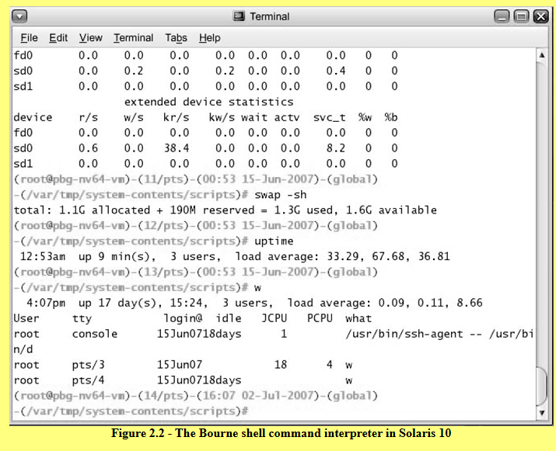
    - Graphical User Interfaces
A Graphical User Interface (GUI) offers a user-friendly way to interact with the operating system using a mouse-driven window and menu system. Users can click icons representing files, programs, and functions on a virtual desktop to perform actions like opening programs or selecting files.
GUIs originated from research at Xerox PARC in the 1970s, with the first GUI appearing on the Xerox Alto in 1973. They gained popularity with the Apple Macintosh in the 1980s, evolving over time with features like the Aqua interface in Mac OS X. Microsoft introduced its GUI with Windows 1.0, built on MS-DOS, later enhancing its functionality and appearance in subsequent versions, including Windows Explorer.
UNIX systems traditionally rely on command-line interfaces (CLI) but also support graphical interfaces like CDE and X-Windows in commercial versions (e.g., Solaris, AIX). Open-source projects like KDE and GNOME provide advanced GUIs for Linux and UNIX, available under open-source licenses.
The choice between CLI and GUI depends on user preference. UNIX users often favor CLI for its powerful shell capabilities, while Windows users primarily use GUIs. Historically, Mac OS only offered a GUI, but Mac OS X introduced both a GUI (Aqua) and CLI due to its UNIX-based kernel.
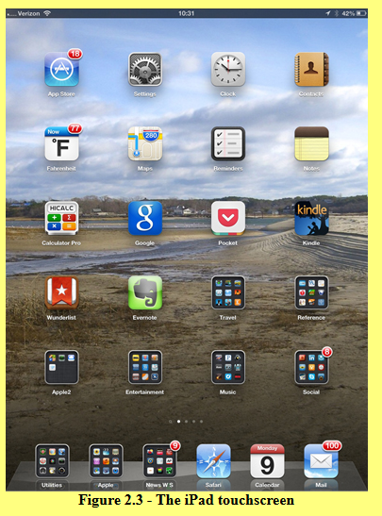

User interfaces vary across systems and are typically independent of the operating system's internal structure. This book focuses on providing adequate services to programs, treating user and system programs equally.
  - System Calls:
System calls provide an interface to the operating system's services, typically written in C/C++ or assembly for hardware-level tasks.
For example, a program copying data between two files uses system calls to:
- Obtain file names (via prompts or GUI menus).
- Open the input file and create the output file.
- Handle errors, like missing files or access issues, by printing messages or terminating the program.
Interactive systems may prompt users to resolve conflicts (e.g., overwriting an existing file) using additional system calls for messages and inputs. Each operation- reading, writing, opening, or closing files-requires specific system calls, demonstrating their integral role in program execution.
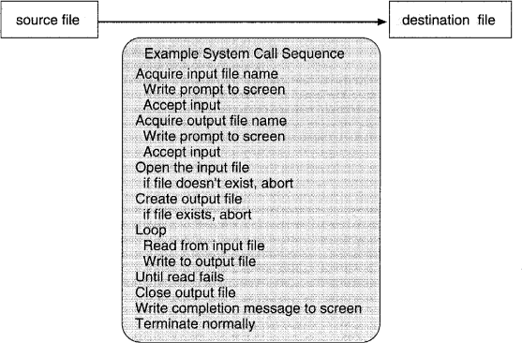

Figure 2.1 Example of how system calls are used

POSIX stands for: Portable Operating System Interface More precisely, the standard name is:
Portable Operating System Interface for UNIX

Example POSIX APIs
- open()
- read()
- write()
- fork()
- exec()
- close()

Systems that support POSIX
- Linux
- macOS
- UNIX
- BSD systems

#include <stdio.h>
#include <fcntl.h>
#include <unistd.h>

int main() {
int fd;
char buffer[50];

fd = open("test.txt", O_RDONLY); // POSIX API

if(fd < 0) {
printf("File open failed\n");
return 1;
}

read(fd, buffer, 50); // POSIX API
printf("File content: %s\n", buffer);

close(fd); // POSIX API

return 0;
}

POSIX API | Header File | Purpose | Example Usage in Code
open() | fcntl.h | Opens a file and returns a file descriptor | fd = open("test.txt", O_RDONLY);
read() | unistd.h | Reads data from a file descriptor | read(fd, buffer, 50);
close() | unistd.h | Closes an open file descriptor | close(fd);

Other Library APIs Used in the Program

Function | Type | Header File | Purpose
printf() | C Standard Library API | stdio.h | Prints formatted output to the console
main() | Program Entry Function | — | Starting point of the program

Java API Example (File Handling)

import java.io.*;

public class Example {
public static void main(String[] args) throws Exception {

FileReader fr = new FileReader("test.txt"); // Java API
BufferedReader br = new BufferedReader(fr); // Java API

String line = br.readLine(); // Java API
System.out.println(line);

br.close(); // Java API
}
}

Java API | Package | Type | Purpose | Example in Code
FileReader | java.io | Class | Opens and reads a file as a character stream | FileReader fr = new FileReader("test.txt");
BufferedReader | java.io | Class | Reads text efficiently by buffering characters | BufferedReader br = new BufferedReader(fr);
readLine() | java.io.BufferedReader | Method | Reads one line of text from the file | String line = br.readLine();
System.out.println() | java.lang | Method | Prints output to the console | System.out.println(line);
close() | java.io.BufferedReader

File Open and Read (Win32 API)

#include <windows.h>
#include <stdio.h>

int main() {

HANDLE file;
char buffer[50];
DWORD bytesRead;

file = CreateFile(
"test.txt", // file name
GENERIC_READ, // read access
0,
NULL,
OPEN_EXISTING,
FILE_ATTRIBUTE_NORMAL,
NULL
); // Win32 API

if(file == INVALID_HANDLE_VALUE) {
printf("File open failed\n");
return 1;
}

ReadFile(file, buffer, 50, &bytesRead, NULL); // Win32 API
printf("File content: %s\n", buffer);

CloseHandle(file); // Win32 API

return 0;
}

Win32 API | Header File | Purpose | Example Usage in Code
CreateFile() | windows.h | Opens or creates a file and returns a handle to the file | file = CreateFile("test.txt", GENERIC_READ, ...);
ReadFile() | windows.h | Reads data from a file or device using the file handle | ReadFile(file, buffer, 50, &bytesRead, NULL);
CloseHandle() | windows.h | Closes an open object handle (such as a file) | CloseHandle(file);

Three Types of APIs (OS-based)

API Type | Description | Used In | Example
🔴 POSIX API | Standard API for UNIX/Linux systems | UNIX, Linux | fork(), exec(), wait()
🟢 Java API | API provided by Java Virtual Machine (JVM) | Platform-independent (Java programs) | Thread, File, Socket
🔵 Windows API | API for Windows OS | Windows systems | CreateProcess(), WaitForSingleObject()

System Call Abstraction through API:
  - APIs (e.g., Win32, POSIX, Java API) abstract system calls, making programming easier and improving portability.
  - APIs map functions (e.g., CreateProcess()) to kernel system calls (e.g., NTCreateProcess()).

Advantages of Using API:
  - Portability: Programs designed with APIs can run on systems supporting the same API.
  - Simplicity: APIs simplify detailed and complex system call operations.
  - Abstraction: The programmer focuses on functionality rather than implementation.

Relationship Among API, System Call Interface, and OS:
  - The API invokes the system-call interface.
  - The system-call interface interacts with the OS kernel to perform the requested operation.
  - Most programmers do not use the low-level system calls directly, but instead use an "Application Programming Interface", API. The following sidebar shows the read( ) call available in the API on UNIX based systems::
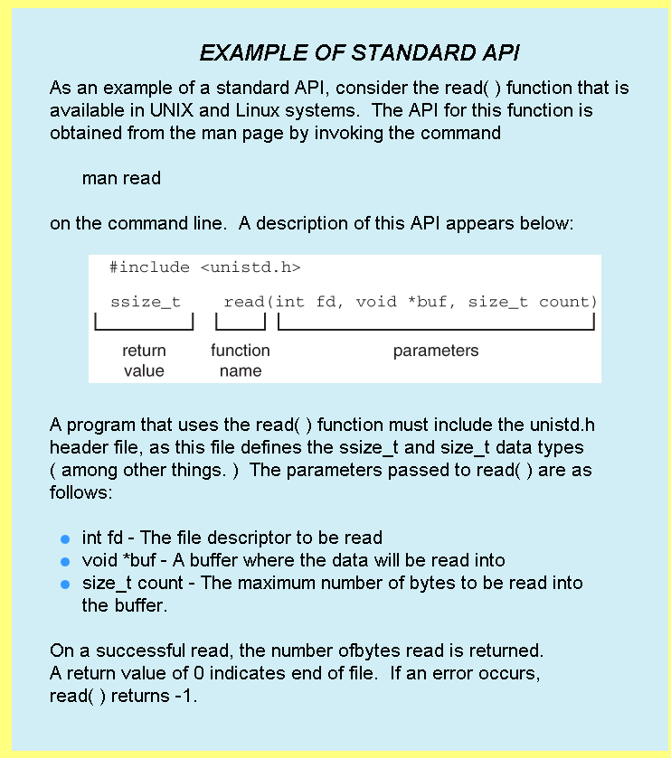

read() you see in a program is usually a library wrapper (API) that internally invokes the kernel system call read()

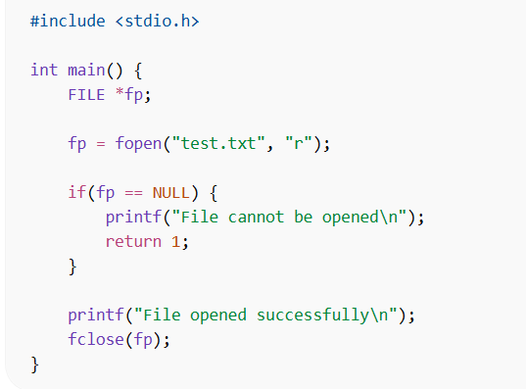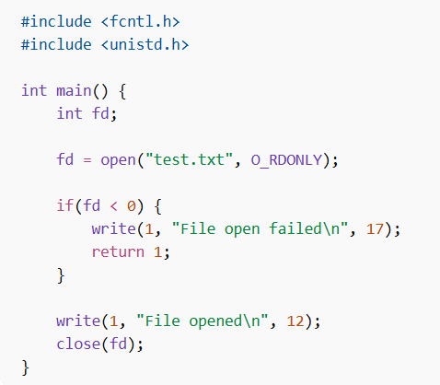

Aspect | fopen() | open()
API Type | C Standard Library API | POSIX API
Header File | stdio.h | fcntl.h, unistd.h
Return Type | FILE * (file pointer) | int (file descriptor)
Level | High-level file handling | Low-level file handling
Buffering | Buffered I/O | Unbuffered I/O
Ease of Use | Easier for general programming | More control over file operations
Portability | Works on many systems (C standard) | Mainly UNIX/Linux systems
Used With | fprintf(), fscanf(), fgets() | read(), write(), close()

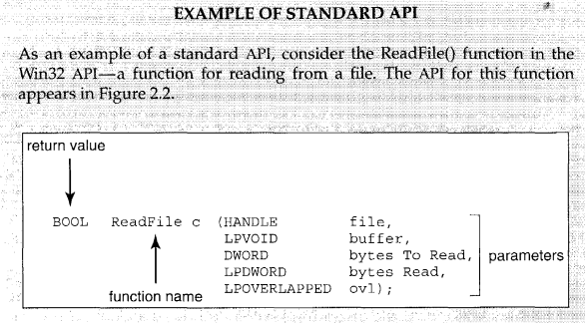

Figure 2.2 The API for the ReadFile() function
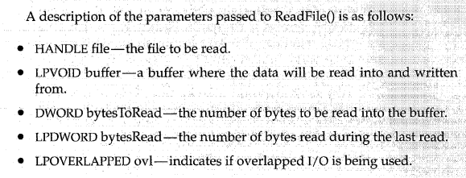

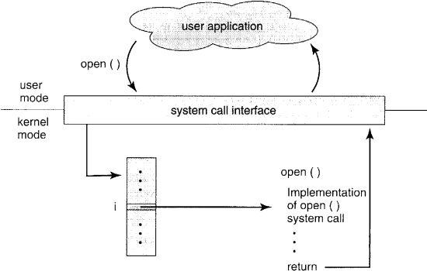

Figure 2.3 The handling of a user application invoking the open() system call System Call Interface:
  - The system-call interface links the API to the operating system.
  - It translates API function calls into kernel system calls, often using a table indexed by system call numbers.
  - The interface manages parameter passing and returns status and result values.

Programmer’s Viewpoint:
  - Programmers do not need to understand the internal implementation of system calls. They only interact with the API and rely on runtime libraries to manage system calls.
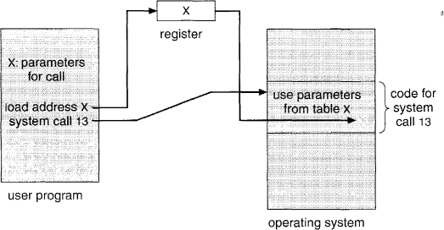

Figure 2.4 Passing of parameters as a table.

System calls vary by operating system and may require parameters like the source file or device, memory buffer address, and length.
There are three common methods to pass parameters to the operating system:
- Registers: Parameters are passed directly in CPU registers.
- Memory block: Parameters are stored in a memory block, and its address is passed in a register (used by Linux and Solaris).
- Stack: Parameters are pushed onto the stack by the program and popped by the operating system.
The block and stack methods are preferred for flexibility, as they allow unlimited parameter size and number.
Analogy Example
- User Program → Customer: The customer wants food but cannot enter the kitchen directly.
- API → Menu Card: The menu lists available dishes; you simply choose without knowing
how cooking is done (like using open(), read(), write()).
- System Call → Waiter: The waiter takes the order and acts as a bridge between customer and kitchen.
- The waiter communicates the request in a format the kitchen understands (user mode → kernel mode).
- Operating System → Kitchen: The kitchen prepares the food and has full access to resources.
Flow: User Program → API → System Call → Operating System

Feature | API (Application Programming Interface) | System Call | System Program
Definition | A set of functions that allow application programs to interact with the OS or libraries | A direct request made by a program to the operating system kernel | Utility programs provided by the OS to perform common tasks
Level | High-level interface | Low-level interface | User-level programs
Purpose | Simplifies access to OS services for programmers | Provides controlled access to kernel services | Provides convenient environment for program development and system usage
Who Uses It | Programmers | Application programs (internally through API) | End users and programmers
Execution Mode | Runs in user mode | Executes in kernel mode | Runs in user mode
Interaction with OS | Calls system calls internally | Directly interacts with the OS kernel | Uses APIs and system calls
Examples | POSIX API, Windows API | open(), read(), write(), fork() | File manager, compiler, text editor, command shell
Role in OS Architecture | Interface between application and system call | Interface between application and kernel | Tools that help users interact with the OS

API (Library Function) | Corresponding System Call | Purpose
printf() | write() | Displays output on the screen
scanf() | read() | Reads input from keyboard
fopen() | open() | Opens a file
fclose() | close() | Closes a file
fread() | read() | Reads data from a file
fwrite() | write() | Writes data to a file
fprintf() | write() | Writes formatted output to a file
fscanf() | read() | Reads formatted input from a file
exit() | exit() | Terminates a process
system() | fork(), exec() | Creates and runs another program
malloc() | brk() / mmap() | Allocates memory
sleep() | nanosleep() | Suspends execution for a time
getchar() | read() | Reads a character from input
putchar() | write() | Writes a character to output

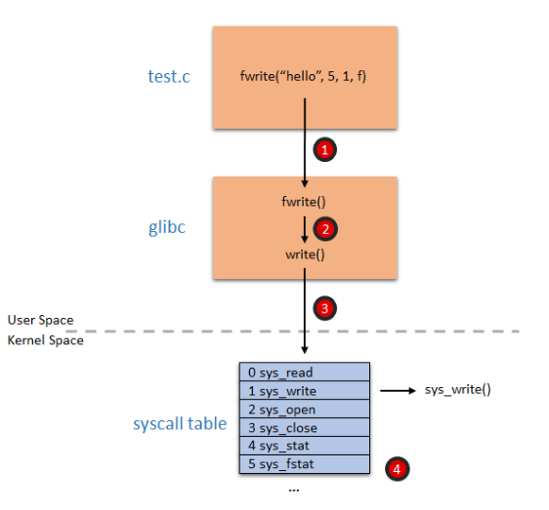

  - Types of System Calls:

System calls can be broadly categorized into five types: process control, file manipulation, device manipulation, information maintenance, and communications. These system calls support various operating system functions, which are detailed in later chapters. Figure 2.5 provides an overview of these system call types.

Type of System Call | Purpose | Examples
Process Control | Manage processes (create, terminate, execute programs) | fork(), exec(), exit(), wait()
File Management | Create, delete, read, write, and manage files | open(), read(), write(), close()
Device Management | Request, release, and operate hardware devices | read(), write(), ioctl()
Information Maintenance | Get or set system information and process details | getpid(), time(), getuid()
Communication | Allow processes to exchange data | pipe(), socket(), send(), receive()
Protection | Control access permissions to resources | chmod(), setuid(), getuid()

- Process control
  - end, abort
  - load, execute
  - create process, terminate process
  - get process attributes, set process attributes
  - wait for time
  - wait event, signal event
  - allocate and free memory
- File management
  - create file, delete file
  - open, close
  - read, write, reposition
  - get file attributes, set file attributes

- Device management
  - request device, release device
  - read, write, reposition
  - get device attributes, set device attributes
  - logically attach or detach devices
- Information maintenance
  - get time or date, set time or date
  - get system data, set system data
  - get process, file, or device attributes
  - set process, file, or device attributes
- Communications
  - create, delete communication connection
  - send, receive messages
  - transfer status information
  - attach or detach remote devices

OS Service | Corresponding Supporting System Call Type | Real-World Examples
User Interface (UI) | Information Maintenance | Getting system time, date, screen resolution, or displaying menus and command prompts.
Program Execution | Process Control | load(), exec(), exit(), abort() to start or terminate programs.
I/O Operations | Device Management | Reading from keyboard, writing to a printer, accessing disk devices.
File-System Management | File Management | create(), delete(), open(), read(), write(), close() files.
Communication | Communication | pipe(), socket(), send(), receive(), or creating network connections.
Error Detection | Information Maintenance / Process Control | Detecting memory errors, disk failures, or terminating faulty processes.
Resource Allocation | Process Control / Device Management | Allocating CPU time, memory, files, or devices among multiple processes.
Accounting | Information Maintenance | Tracking CPU usage, memory usage, number of processes, or system logs.
Protection and Security | Protection | set_permission(), get_permission(), authentication and access control mechanisms.

Figure 2.5 Types of system calls

    - Process Control
A running program can terminate normally (end) or abnormally (abort). In case of an abnormal termination or error, the system may generate a memory dump and error message for debugging. The operating system then transfers control to the command interpreter. In interactive systems, the interpreter processes the next command, while in GUI systems, a pop-up may alert the user. In batch systems, the job is typically terminated, and the next job is executed.

Some systems use control cards (batch system commands) for error recovery actions. Errors can be categorized with levels, where level 0 indicates normal termination. This helps the command interpreter or subsequent programs decide on the next steps automatically.
A running program may load and execute another program, triggered by user commands, mouse clicks, or batch commands. Control after the new program's termination can either return to the original program (requiring its memory to be saved) or allow both programs to run concurrently, creating a new job or process.
New jobs or processes require management, including setting or modifying attributes like priority and execution time, and may be terminated if no longer needed. This functionality is supported by system calls for creating, managing, or terminating processes.
System calls often handle process coordination, debugging, and performance analysis. Processes may need to wait for specific events (wait event) or time durations (wait time) and signal when those events occur (signal event), which are crucial for managing concurrent processes.

Debugging support includes memory dumps, program tracing (tracking executed instructions), and single-step CPU modes for detailed analysis. Time profiling tracks execution time at various program locations using timer interrupts or tracing, offering insights into program performance.
For example, MS-DOS, a single-tasking system, runs programs by loading them into memory, overwriting most of itself to maximize available memory. The command interpreter resumes after the program terminates, reloads itself, and provides any saved error codes for user or subsequent program use.
FreeBSD, a multitasking system, allows users to run a shell that accepts commands and executes programs. Unlike MS-DOS, FreeBSD's shell can continue running while executing other programs. To start a new process, the shell uses the fork() system call to create a process and exec() to load and run a program.
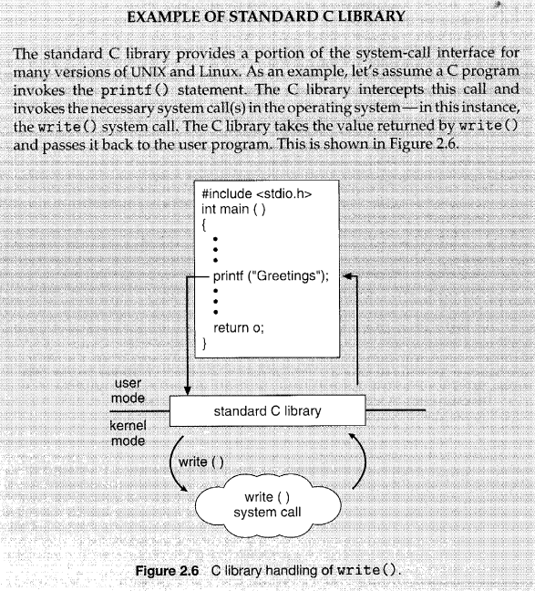

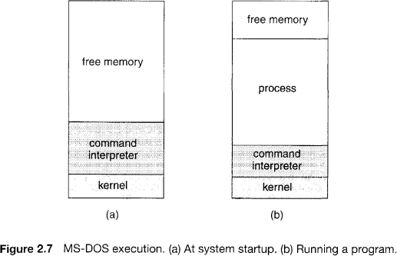

Depending on the command, the shell either waits for the process to finish or runs it in the background. Background processes handle I/O through files or a GUI since the shell controls the keyboard. Users can execute other commands, monitor processes, or adjust priorities concurrently. When a process completes, it uses the exit() system call to terminate, returning a status code to the shell or invoking process.
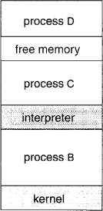

Figure 2.8 FreeBSD running multiple programs.
    - File Management
The file system, discussed in later chapters, involves several key system calls. These include creating and deleting files, which require the file name and attributes. Once created, files need to be opened for use, with operations like reading, writing, or repositioning (e.g., rewinding).
After usage, files should be closed. For directories, similar operations apply, along with the ability to retrieve and reset file attributes, such as name, type, and protection codes. Additional system calls may support tasks like file moving and copying, and some operating systems offer APIs or system programs to perform these operations.

    - Device Management
A process requires various resources, such as memory, disk drives, and file access, to execute. If resources are available, they are granted; otherwise, the process must wait. Resources, both physical (e.g., tapes) and virtual (e.g., files), are controlled by the operating system.
For exclusive use, a device must be requested and released once finished, similar to the open and close system calls for files. Many operating systems, like UNIX, treat devices and files similarly, allowing the same system calls for both. Some systems may identify devices using special file names or attributes, making the user interface appear unified despite different underlying system calls.

    - Information Maintenance
Many system calls are used to transfer information between the user program and the operating system, such as retrieving the current time, system statistics (e.g., number of users, OS version, free memory), or process information. System calls are also used to access and modify process attributes, such as getting and setting process details.

    - Communication
There are two common models of inter-process communication: message passing and shared memory. In the message-passing model, processes exchange messages either directly or via a mailbox, requiring a connection to be established. Communication happens through system calls like "open connection" and "accept connection." Daemon processes usually wait for connections from clients and exchange messages using "read" and "write" system calls.
In the shared-memory model, processes use system calls like "shared memory create" and "shared memory attach" to access regions of memory owned by other processes. This model allows fast communication but requires careful synchronization to avoid conflicts. Both models are widely used, with message passing being easier for cross-computer communication and shared memory offering faster communication within a computer.

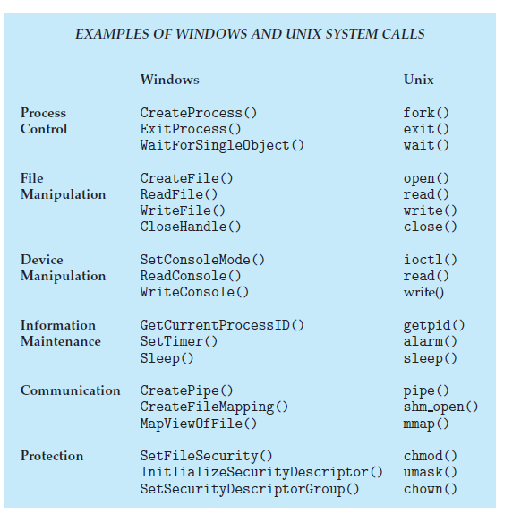
    - Protection
Protection provides a mechanism for controlling access to the resources provided by a computer system. Historically, protection was a concern only on multiprogrammed computer systems with several users. However, with the advent of networking and the Internet, all computer systems, from servers to
mobile handheld devices, must be concerned with protection.
Typically, system calls providing protection include set permission() and get permission(), which manipulate the permission settings of resources such as files and disks. The allow user() and deny user() system calls specify whether particular users can—or cannot—be allowed access to certain resources.

  - System Programs:

Modern systems include various system programs that provide an environment for program development and execution. These programs can be categorized as follows:
- File Management: Programs for creating, deleting, copying, renaming, and manipulating files and directories.

- Status Information: Programs that retrieve system status such as date, time, available memory, or performance data, and display it on terminals or in windows.
- File Modification: Text editors and commands for creating and modifying file content, and searching or transforming text.
- Programming Language Support: Compilers, assemblers, debuggers, and interpreters for languages like C, Java, and PERL.
- Program Loading and Execution: Systems for loading and executing compiled programs, including loaders and debugging tools.
- Communications: Programs enabling virtual connections for messaging, browsing, email, remote login, and file transfers.
These system programs facilitate program development, management, and communication within the system.

category of System Program | Description | UNIX / Linux Examples | Windows Examples
File Management | Programs to create, delete, copy, rename, and manage files and directories. | cp, mv, rm, mkdir, ls | File Explorer, copy, move, del, mkdir
Status Information | Programs that display system status such as date, time, memory usage, or performance data. | date, top, free, uptime | Task Manager, systeminfo, date, time
File Modification | Programs used to create or modify file content and search or transform text. | vi, nano, sed, grep | Notepad, WordPad, PowerShell editors
Programming Language Support | Tools used to develop programs such as compilers, interpreters, and debuggers. | gcc, javac, python, gdb | Visual Studio, javac, python, .NET SDK
Program Loading and Execution | Programs that load and run compiled programs. | ld (linker), exec, bash | Windows Loader, cmd, PowerShell
Communications | Programs used for networking, messaging, remote login, and file transfer. | ssh, ftp, scp, web browsers | Remote Desktop, ftp, Outlook, web browsers

In addition to system programs, operating systems come with utility programs or application software designed for common tasks, such as web browsers, word processors, spreadsheets, database systems, and games.
The user experience is shaped by these applications and system programs rather than the underlying system calls. For example, on a mac OS system, a user might interact with a GUI or a command-line UNIX shell, both of which use the same system calls but present them in different ways.

System Programs | Utility/Application Software
Come with OS | Installed by user
Support development & execution | Perform user tasks
Use system calls | Also use system calls
Example: compiler | Example: MS Word

System Calls → Low-level kernel interface
System Programs → User-level tools using system calls
Applications → Built on top of system programs & system calls
Analogy
Kernel = Engine
System Calls = Engine controls
System Programs = Steering wheel, pedals
Applications = Driving experience

Example of a System Call (C Program)
A system call directly requests a service from the OS kernel.
Example: write() system call in Linux
write() is a POSIX API function (library wrapper).
But it invokes the write system call inside the kernel.
#include <unistd.h>
int main() {
write(1, "Hello OS\n", 9); // 1 = standard output (screen)
return 0;
}

- write() is a system call
- It directly interacts with the OS kernel
- It sends output to the screen using kernel services
Other examples:
- open()
- read()
- fork()
- exec()

Example of a System Program
A system program is a utility that uses system calls internally.
Example: ls command in Linux
ls

What happens?
- ls is a system program (utility)
- It internally uses system calls like:
  - open()
  - read()
  - close()
- It lists files in a directory
Other examples:
- cp
- rm
- mkdir
- gcc
If it directly communicates with the kernel inside a program, it is a system call. If it is a command-line utility that uses system calls internally, it is a system program.
Category | Purpose | Examples (System Programs)
File Management | Create, delete, copy, rename files & directories | cp, mv
Status Information | Display system status (date, memory, CPU, processes) | date, top
File Modification | Create and modify file contents | vim, nano
Programming Language Support | Compile, interpret, debug programs | gcc, javac
Program Loading & Execution | Load and execute programs | ld, exec
Communications | Enable remote login & file transfer | ssh, ftp

OS Service | Supporting System Call Type | Corresponding System Program Category | Real-World Examples
User Interface (UI) | Information Maintenance | Status Information | Showing date/time, system status on terminal or GUI dashboard
Program Execution | Process Control | Program Loading and Execution | exec(), exit(), loader starting a program
I/O Operations | Device Management | Communications / File Management | Reading keyboard input, printing, network I/O
File-System Management | File Management | File Management | create(), delete(), open(), read(), write()
Communication | Communication | Communications | pipe(), socket(), message passing between processes
Error Detection | Information Maintenance / Process Control | Status Information | System monitoring tools detecting errors or crashes
Resource Allocation | Process Control / Device Management | Program Loading and Execution | CPU scheduling, memory allocation while running programs
Accounting | Information Maintenance | Status Information | Monitoring CPU usage, system logs, performance reports
Protection and Security | Protection | File Management / Programming Language Support | Access permissions, authentication, security libraries

Category | Number of Types | Types / Examples
OS Services | 9 | User Interface, Program Execution, I/O Operations, File-System Manipulation, Communication, Error Detection, Resource Allocation, Accounting, Protection & Security
System Call Types | 6 | Process Control, File Management, Device Management, Information Maintenance, Communication, Protection
System Programs | 6 | File Management, Status Information, File Modification, Programming Language Support, Program Loading & Execution, Communications
API Types | 3 (Commonly Referenced) | POSIX API, Win32 API, Java API

  - Operating-System Structure:
Modern operating systems are large and complex, requiring careful engineering for proper functionality and ease of modification. A common approach is to divide the system into smaller, well-defined modules, each with clear inputs, outputs, and functions. These modules are then interconnected and integrated into the system's kernel.

Structure | Key Idea | Example
Simple | No clear modular design | MS-DOS
Layered | OS divided into layers | THE OS
Microkernel | Minimal kernel, services in user space | Mach, MINIX
Modules | Dynamic loadable kernel modules | Linux
Hybrid | Combination of different structures | Windows, macOS, Android

Structure | Key Idea | Kernel Type | Example
Simple | No clear modular design | Monolithic | MS-DOS
Layered | OS divided into layers | Monolithic (structured in layers) | THE OS
Microkernel | Minimal kernel, services in user space | Microkernel | Mach, MINIX
Modules (Modular Kernel) | Dynamic loadable kernel modules | Monolithic (with modular extensions) | Linux, Solaris
Hybrid | Combination of different kernel structures | Hybrid Kernel | Windows, macOS, Android

    - Simple Structure
Many commercial operating systems, like MS-DOS, lack well-defined structures. MS-DOS, initially designed to be simple and compact, grew beyond its original scope without modular design. It allows direct access to basic I/O routines, making it vulnerable to system crashes due to faulty programs. MS-DOS was also limited by hardware, as the Intel 8088 lacked dual-mode and hardware protection.

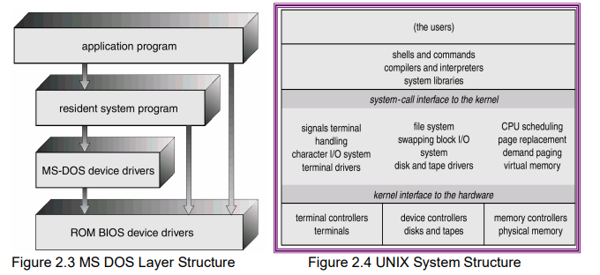

Similarly, the original UNIX system had limited structuring, consisting of a kernel and system programs. The kernel, which provides essential OS functions, was initially monolithic and difficult to implement and maintain, especially given the hardware limitations at the time. Over time, UNIX evolved with additional interfaces and device drivers.
    - Layered Approach
Modular Operating Systems: With proper hardware support, OSes can be modularized into smaller, manageable components, offering better control and flexibility compared to older systems like MS-DOS or UNIX.
Top-Down Design: The system’s functionality is divided into components. Information hiding allows programmers to implement low-level routines independently as long as interfaces and tasks remain consistent.

Layered Approach:
- The OS is divided into layers (e.g., hardware at the bottom, user interface at the top).
- Each layer provides services to the layer above and relies on the layer below.

Advantages of Layering:
- Simplifies construction, debugging, and verification.
- Errors in a layer are easier to isolate since lower layers are pre-debugged.
- Each layer operates abstractly, needing only to know what lower-layer operations do, not how they are implemented.
Abstraction and Simplification: Layers hide data structures, operations, and hardware details from higher layers, simplifying design and implementation.
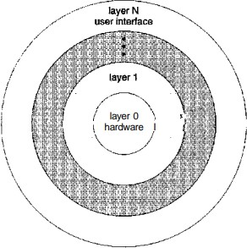

Figure 2.11 A Layered operating system.
Limitations of the Layered Approach:
- Difficulty in Defining Layers:
  - Proper layer definition requires careful planning since each layer depends on lower ones.
  - Example: The backing-store driver must be below memory management but may also need to interact with the CPU scheduler, creating conflicts.

- Complex Dependencies:
  - Dependencies can be non-obvious, e.g., in large systems, the CPU scheduler may rely on memory-swapped data, requiring the backing-store driver to be below it.
- Efficiency Issues:
  - Layered systems introduce overhead. A system call must pass through multiple layers (e.g., I/O → memory management → CPU scheduling → hardware), increasing execution time compared to nonlayered systems.
- Modern Trends:
  - To address these issues, newer designs use fewer layers with more functionality, balancing modularity with reduced complexity and overhead.
    - Microkernels
- A microkernel is an operating system design where only essential functions like process management, memory management, and interprocess communication run in the kernel, while other services run in user space.
User Applications
│
User-Level Services
(File System, Drivers, Networking)
│
Microkernel
(Process mgmt, Memory mgmt, IPC)
│
Hardware

Concept:
- Microkernels remove nonessential components from the kernel, implementing them as user-space programs, resulting in a smaller kernel.
- Typically, they provide minimal process and memory management along with a communication facility.

Communication:
- Uses message passing for interaction between client programs and user-space services. Clients communicate with services indirectly via the microkernel.

Advantages:
- Extensibility: New services can be added to user space without modifying the kernel.
- Portability: Easier to adapt to different hardware designs.
- Security and Reliability: Failures in user-space services do not impact the kernel or other services.

Examples:
- Mach: Provides UNIX compatibility by mapping system calls into messages.
- QNX: A real-time OS with a microkernel handling message passing, process scheduling, networking, and hardware interrupts.

Challenges:
- Performance Issues: Increased overhead from system functions can degrade performance.
- Example: Windows NT started with a microkernel but shifted toward a more monolithic design in later versions (e.g., Windows XP) to improve performance.
    - Modules
Modular Kernel Design and Hybrid Structures
A Modular Kernel Design is an operating system structure where the kernel is divided into separate modules, and these modules can be loaded or removed dynamically while the system is running.
Instead of placing everything inside a single large kernel, the system keeps a core kernel and allows additional functionalities to be added as modules.
User Applications
│
System Call Interface
│
Core Kernel
(Process management, Memory management)
│
Loadable Kernel Modules
(Device Drivers, File Systems, Network Modules)
│
Hardware

- Modular Kernel Design:
  - Modern operating systems use object-oriented programming to create modular kernels.
  - Core components provide essential services, while additional services are dynamically linked at boot time or runtime.
  - Dynamically loadable modules are used in systems like Solaris, Linux, and Mac OS X, allowing flexibility and scalability.
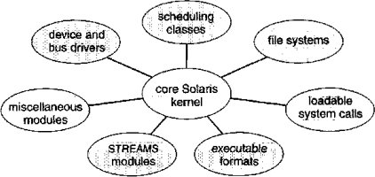

Figure 2.12 Solaris loadable modules
- Example: Solaris:
  - Solaris kernel has core components and supports seven types of loadable modules:
    - Scheduling classes
    - File systems

    - Loadable system calls
    - Executable formats
    - STREAMS modules
    - Miscellaneous
    - Device and bus drivers
  - Modules can call one another, combining the efficiency of monolithic kernels with the flexibility of microkernels.
The Solaris Modular Approach is used by the Solaris Operating System, which was developed by Sun Microsystems (now owned by Oracle).

Operating System | Developer | Structure Type
Solaris | Sun Microsystems / Oracle | Modular Kernel
OpenSolaris | Sun Microsystems | Modular Kernel
Illumos-based systems (OpenIndiana, SmartOS) | Illumos community | Modular Kernel

- Hybrid Structure: Mac OS X (Darwin):
  - Layered design:
- Top layers: Application environments and graphical services.
- Kernel environment: Combines the Mach microkernel and BSD kernel.
Mach kernel: Provides memory management, thread scheduling, IPC, and RPC.
BSD kernel: Offers networking, file systems, POSIX APIs, and Pthreads. Includes an I/O kit for device drivers and kernel extensions.
Applications can utilize both Mach and BSD facilities directly.
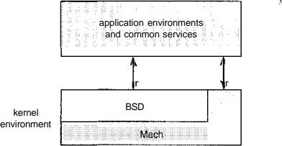

Figure 2.13 The Mac OS X structure.

Operating System | Structure Type | Architecture Components | Kernel Type | Key Features
macOS | Hybrid Structure | Cocoa → Media → Core Services → Core OS | XNU (Mach + BSD hybrid) | High performance, strong security, modular components
iOS | Hybrid Structure | Cocoa Touch → Media → Core Services → Core OS | XNU hybrid kernel | Touch-based interface, energy-efficient design, application sandboxing
Android | Hybrid / Modular (Linux-based) | Applications → Application Framework → Android Runtime (ART) → Native Libraries → Linux Kernel | Linux-based kernel | Open-source, multitasking support, large app ecosystem

Concept | Description | Developed By / Used In | Key Notes
Mach | A microkernel that provides basic OS services such as process scheduling, memory management, and interprocess communication. | Carnegie Mellon University | Forms the core microkernel component in Apple's XNU kernel.
BSD (Berkeley Software Distribution) | A UNIX-based operating system providing networking, file systems, and POSIX system calls. | University of California, Berkeley | Provides UNIX functionality in macOS and iOS.
XNU Kernel | Hybrid kernel combining Mach microkernel and BSD components. | Apple | Used in macOS, iOS, iPadOS, watchOS, and tvOS.
XNU Full Form | “X is Not Unix.” | Apple | Indicates it is UNIX-based but not a traditional UNIX kernel.
macOS | Desktop operating system designed for Apple computers. | Apple | Optimized for multitasking, keyboard, mouse, and desktop environments.
iOS | Mobile operating system designed for Apple mobile devices. | Apple | Optimized for touchscreen interaction and battery efficiency.
Cocoa Framework | Software framework used to develop macOS applications with graphical interfaces. | Apple | Provides libraries, tools, and APIs for building macOS GUI applications.

